**Project Design Phase-II**

**Technology Stack (Architecture & Stack)**

|  |  |
| --- | --- |
| Date | 03 October 2022 |
| Team ID | PNT2022TMID53936 |
| Project Name | Project – Crude Oil Price Prediction |
| Maximum Marks | 4 Marks |

**Technical Architecture:**

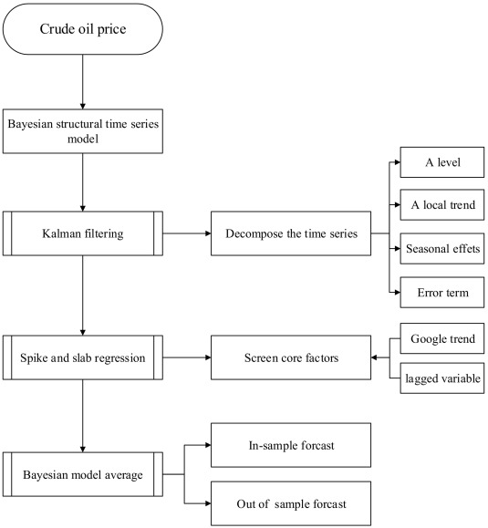

**Table-1 : Components & Technologies:**

|  |  |  |  |
| --- | --- | --- | --- |
| **S.No** | **Component** | **Description** | **Technology** |
|  | User Interface | Web UI and Mobile App | HTML, CSS, JavaScript / Angular Js / React Js etc. |
|  | Prediction | For the Prediction of the Price | Python |
|  | Web Application | For the web app | Python (Flask) |
|  | Database | Email, Phone Number, Age, and Name (String, Integer, Integer, and String | MySQL, NoSQL |
|  | Cloud Database | Database Service on Cloud | IBM DB2, IBM Cloudant etc |
|  | File Storage | File storage requirements | IBM Block Storage or Other Storage Service or Local Filesystem |
|  | Machine Learning Model | Recurrent Neural Networks | Object Recognition Model, etc. |
|  | Infrastructure (Server / Cloud) | Application Deployment on Local System / Cloud Local Server Configuration: i5 4th gen, 16 GB of ram  Cloud Server Configuration: i3 4th gen, 4 GB ram | Kubernetes |

**Table-2: Application Characteristics:**

| **S.No** | **Characteristics** | **Description** | **Technology** |
| --- | --- | --- | --- |
|  | Open-Source Frameworks | Flask | Web Application |
|  | Security Implementations | OAuth Authentication | Authentication is provided by Google or Facebook or any available providers |
|  | Scalable Architecture | Microservices | AWS Lambda |
|  | Availability | Distributed Servers | CDN |
|  | Performance | 25,000 Requests Servers | Flask |

**References:**

[**https://www.sciencedirect.com/science/article/pii/S0140988320300608**](https://www.sciencedirect.com/science/article/pii/S0140988320300608)